|  |  |  |
| --- | --- | --- |
| Internship Project Title | UI testing Using Selenium WebDriver and cucumber. |  |
| Name of the Company | TCS iON |  |
| Name of the Industry Mentor | Debashis Roy |  |
| Name of the Institute | ICT Accademy |  |

|  |  |  |  |  |
| --- | --- | --- | --- | --- |
| Start Date | End Date | Total Effort (hrs.) | Project Environment | Tools used |
| 31/03/2023 | 12/03/2023 | 125 | Java Hot Spot(TM) 64-Bit Server VM 17.0.6+9-LTS-190, cucumber-jvm 7.11.2, Windows 11 | Microsoft Excel, VSDC Video Recorder, Selenium WebDriver, Cucumber-jvm, JDK,JVM, Chrome Browser. |

APPROACH

A test approach is the test strategy implementation of a project, defines how testing would be carried out.

* Risks of product or risk of failure or the environment and the company.
* Expertise and experience of the people in the proposed tools and techniques.
* Regulatory and legal aspects, such as external and internal regulations of the development process.
* The nature of the product and the domain.

LOGIC FLOW

FLOWCHART

Start

Open the browser

Enter the url and user is on login page

Enter the email

Enter the valid email id

Whether the email is valid format?

N

Y

Enter the password

Click on the login Button

Whether login is successful?

N

Y

END

Customer Front End -Update Profile

Start

Login with valid credentials

Click On My Profile

Enter the Address details

Click on the Update Profile

Profile Updated Successfully Message will appear.

End

Customer Front End-Issue Voucher

Start

Agent Login with valid credentials

A Dashboard will appear. Click On My Bookings

A new page will appear

Click On View Voucher

Click on Download Invoice

An Image is Downloaded in My Downloads

Open the file and check Invoice is visible**?**

n

y

End

Agent Front End-Search Hotels by City

Start

Login with valid credentials

Click on hotels

Enter the name of the city

Select the date and number of passengers

“No Results Found” message will be displayed

Click on Search

Check the city entered is valid ?

n

y

Rates and Available hotels will appear

End

Agent Front End-To Add an amount of 50USD using PayPal

Start

Login with valid credentials

Click on Add funds

Select the payment method as “Pay with PayPal”

Enter the Amount in USD

Click on Pay Now

A new window will appear showing Pay pal and Back to Invoice

Whether to proceed the payment ?

n

Click Back to Invoice

y

Click on Pay pal

A dialog box “Are you sure” will appear

Enter Pay pal Account details

Click On Yes

Make Payment by adding the debit card

End

Admin Backend -To delete an Invoice

Start

Login With Valid Credentials

A Dashboard will appear

Click on Bookings

Select the Booking Status “Pending”

Change the Booking status to Cancelled

Delete the Invoice using the Delete button

End

Verify The Dashboard Count

Start

Login using valid credentials

Take the Count of Confirmed Bookings in the dashboard using getText()

Store the Value as a variable “X”

Change the booking status from pending to confirmed

Incriment the value of X by 1.

Take the Count of Confirmed Bookings in the dashboard using getText()

Store the Count as a variable Y

n

ERROR

CHECK IF X=Y ?

y

Count is Verified

End

**Enhancements Suggested**

**Agent Front End**

* Hotel Search should provide the Cities by state
* For non valid cities ,It can display invalid option
* To provide the details of Hotels by City is a Bug

**Customer Front End**

* Payment of USD 50 using PayPal should have Test Values for adding money
* For a Tester its difficult to test using real Bank Account details
* If the amount is updated from USD to INR ,till the payment option only accepts USD amount.
* According to the currency change it should accept the amount in that currency
* The Language of the Website is changing Simultaneously, so the language should be fixed.
* Sometimes the website is taking more time to load pages, so kindly note this.
* The cookies of the website are asking every time to accept it when we launch the website.
* Even by Entering the valid Email and password ,Sometimes the website is showing the Error Message.

**Admin Back End**

* The Confirmed and paid Bookings can be changed into Pending And unpaid Bookings. So If a booking is Confirmed and paid then it only be cancelled no further actions can be done.

**Supplier Back End**

* Booking Module is not working
* The flight module is not displayed. Details of the flights are not available for Suppliers. Its a Major issue.
* Visa Module is not displayed. Visa Details and the expiry dates are not available. It is a critical functionality.

**Solution And Templates**

**Supplier Back End**

**Visa Module**

* The fields should contain Reference No, Full name, Date of Birth, Nationality, Travel Document Number, Submit to, Last Uploaded date.
* It should contain the Functions such as Check Status, Apply for new Visa, To manage Visa Applications.

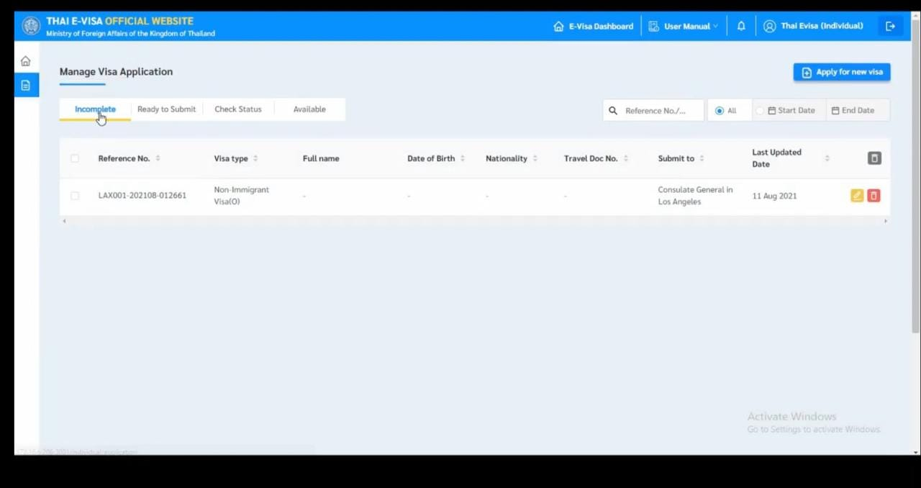

**Flight Module**

* It should contain the destination details of both Boarding and Un boarding.
* The departure and return date, number of passengers, number of children.
* Option to select the travel class, then to Search for flight.

